The ACT and the SAT are very different college entrance exams.
How Do They Differ?  Exams are used to help colleges evaluate applicants.  The SAT is a three-part aptitude test (reading, math, and writing).  The ACT is an achievement test with four core sections (English, math, reading, and science) and an optional writing section. |  | ACT | SAT
 | Length | 3 hours, 25 minutes  (optional 30-minute writing Test) | 3 hours,  45 minutes
 | Sections | 4 sections:  English, math, reading, science,  writing (optional; required by some colleges) | 10 sections:  3 critical reading, 3 math,  3 writing (including essay),  1 experimental (not scored)
 | Score  Composition | ¼ English, ¼ math,  ¼ reading, ¼ science | 1/3 math, 1/3 reading, 1/3 writing
 | Scoring | Composite score 1-36 based on  average of 4 sections:  English, math, reading, science  (Score 0-12 for Optional Essay) | Aggregate score 600 - 2400  based on total of 3 scores  200- 800 each  (critical reading, math, writing)
 | Guessing  Penalty | No penalties for incorrect answers | Penalties  (typically ¼ point  deducted) for wrong answers
 | Essay | Optional (final section) | Required
 | Cost | $36.50 ACT only;  $52.50 ACT plus writing | $51 for all three sections
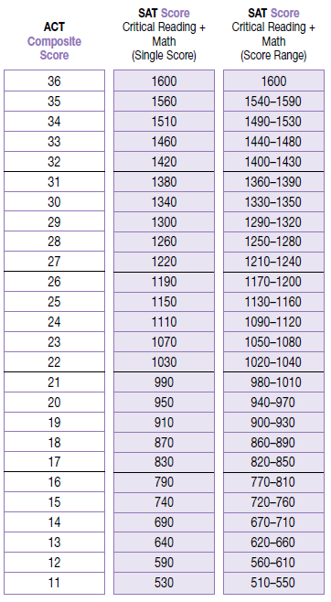
The ACT and SAT are different tests that measure similar, but distinct constructs.

ACT-SAT Concordance
The ACT measures achievement related to high school curricula, while the SAT measures general verbal and quantitative reasoning. ACT and the College Board have completed a concordance study that is designed to examine the relationship between two scores on the ACT and SAT. These concordance tables (such as the one to the left) do not equate scores, but rather provide a tool for finding comparable scores.

You can find the concordance tables and guidelines for proper use online at: www.act.org/solutions/college-career-readiness/compare-act-sat.
(Issued June 2008)

