Scores: What Colleges Want on the ACT or SAT (Based on Undergraduate Admissions Fall of 2013)*

College | ACT Comp  (Mid 50%) | SAT CR  (Mid 50%) | SAT Math  (Mid 50%)
Clemson University | 26-31 | 560-660 | 590-680
College of Charleston | 23-27 | 550-650 | 560-650
Converse College | 20-26 | 470-600 | 460-570
Lander University | 18-22 | 430-540 | 450-540
USC– Columbia | 24-29 | 540-640 | 560-650
USC– Upstate | 18-22 | 430-520 | 440-520
Winthrop University | 20-25 | 460-580 | 470-570
Wofford College | 23-28 | 570-630 | 590-680
Spartanburg Methodist College | 18-23 | 400-499 | 400-499
Spartanburg Community College | 19 Math***  19 English | 480*** | 480***
SC Life Scholarship** | 24** | 1100**  Critical Reading + Math Combined
* College scores reported by www.bigfuture.collegeboard.org
**Other requirements apply; see your School Counselor or visit:
www.che.sc.gov for more information
***Minimum scores required to avoid remedial courses, which do not count toward college graduation and are not covered by South Carolina Lottery Scholarship Programs.

2014-2015 ACT and SAT Testing Dates
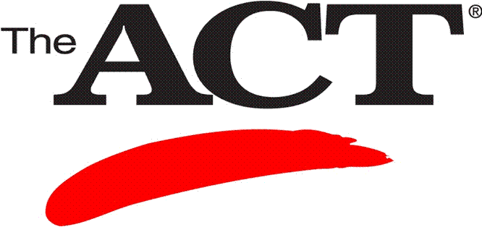 | 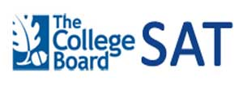
October 25, 2014 | October 11, 2014
December 13, 2014 | November 8, 2014
February 7, 2015 | December 6, 2014
April 18, 2015 | January 24, 2015
June 13, 2015 | March 14, 2015
 | June 6, 2015
Additional information at: www.actstudent.org | Additional information at: www.collegeboard.org

