

**20 Jobs Predicted to Have the Most Openings in the Upstate (2010-2020)**



*Source: SC Department of Employment & Workforce*

Average Annual Wage by Industry in the Spartanburg Area

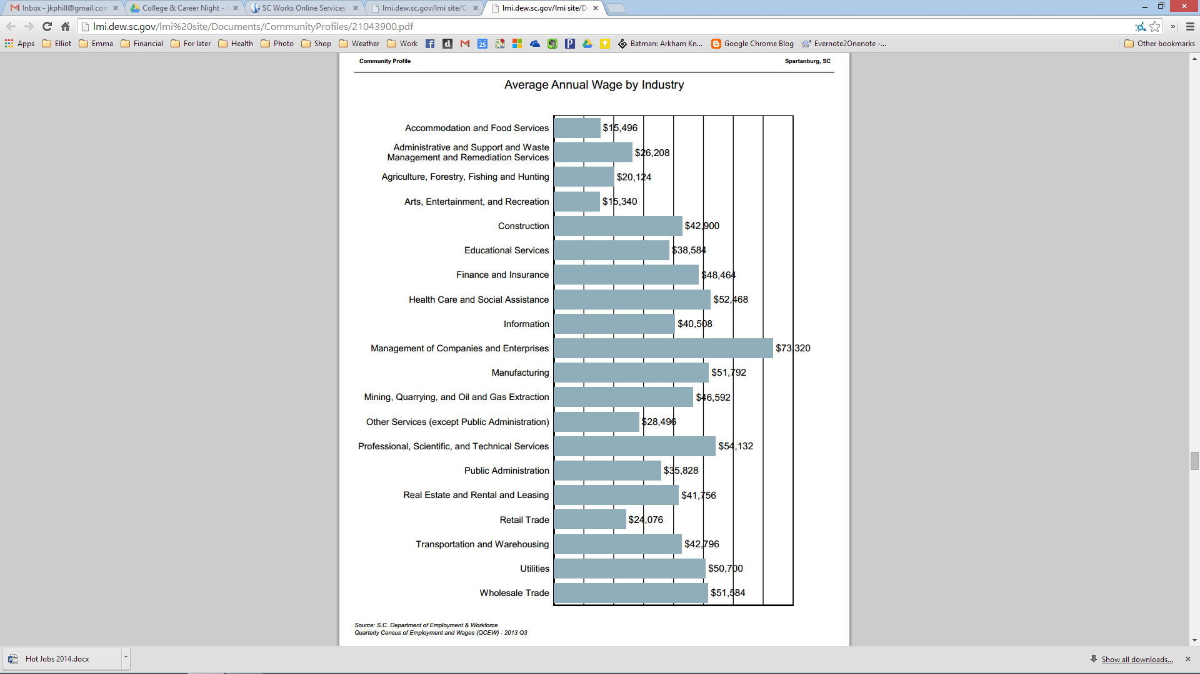

*Source: SC Department of Employment & Workforce Quarterly Census of Employment and Wages (QCEW) – 2013 Q3*